**Flash**

**Experiment: 1**

**Write down the procedure to create an animation to represent the growing moon.**

* Open flash 5 software **->** click on flash document **->** go to windows **->** properties **->** select the properties tool **->** choose the Background to black.
* Go to fill color under tool bar **->** select the white color.
* Select the oval tool in order to draw the moon. u will get a white circle.
* Select the oval tool in order to draw the moon. u will get a white circle.
* Select the white circle on the worksheet using the selection tool **->** right click **->** convert to symbol **->** select movie clip **->** give suitable name eg: moon **->** click ok.
* Go to filter **->** click on the **+** symbol **->** select glow to apply glowing effect **->** select the color to white under glow and adjust the blur x/blur y values.
* Click on the **+** symbol again and chose blur **->** again adjust the blur x/blur y values.
* Place the moon where ever you want on the work area.double click on layer 1 and rename as MOON. 9. Insert another layer **->** rename it as Animation.
* Select the fill color to black**->** select oval tool and draw a circle on the moon to cover the moon->select the newly added circle**->** right click-> convert to symbol-> movie clip-> name it as Animation.
* Go to filter-> select + symbol->give the glow and blur effect as did for moon.
* Select the 150th frame in moon layer->right click->insert key frame. repeat the same for Animation layer.
* Click on the 149th keyframe of animation layer ->right click->press create motion-> select the animation movie clip and move slowly across the moon.
* Finally go to control-> test movie-> u will get a growing moon as the output.

**Output:**

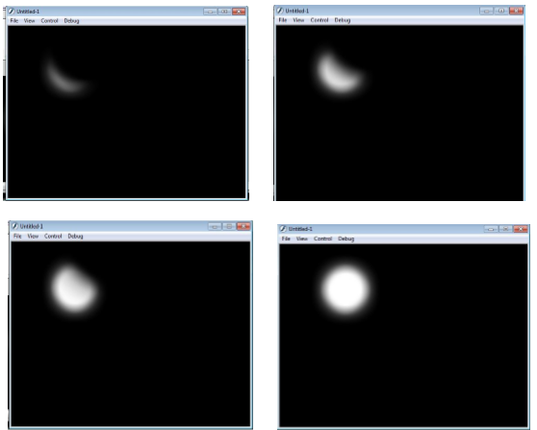

**Experiment: 2**

**Write down the procedure to create an animation to indicate a ball bouncing on steps.**

* Go to start- macromedia- click on flash document
* select the line tool and draw the steps. colour it using the paint bucket tool
* Select the circle from the tool bar and create a circle on the work area.
* Now fill the colour to the circle using the paint bucket tool from the tool bar.
* Go to frames right click on the first frame and choose insert key frame.

slightly move the ball. Repeat the same procedure by adding new key frames to

show the ball change the shape of the ball slightly when it touches the surface.

* In order to change the shape use the free transform tool.
* Go to control and click on test movies .you will observe the ball bouncing on steps.

**Output:**

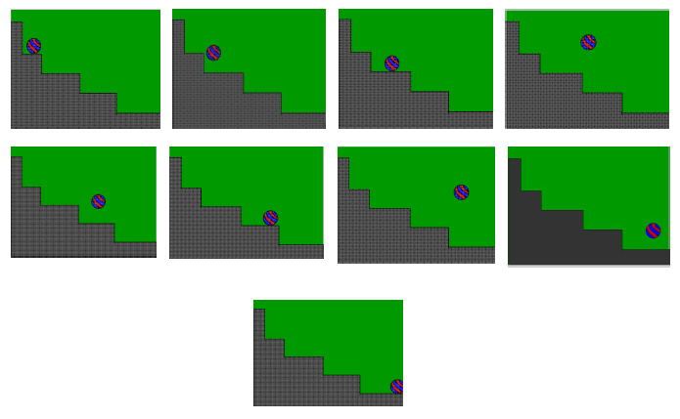

**Experiment: 3**

**Write down the procedure to simulate movement of a cloud.**

* go to start- macromedia- click on flash document
* create a blue background in layer 1
* Now insert a layer 2 and draw the clouds in this layer.
* in order to create the clouds, go to tool bar and select pencil option, draw the cloud in layer2
* fill the colour to the cloud, right click on it- choose convert to symbol option- give the name as cloud
* select the movie clip option and click ok.
* Go to filter->click on the + symbol->select glow to apply glowing effect-> select the colour to white
* under glow and adjust the blur x/blur y values.
* give the appropriate blur effect to the cloud.
* go to frames, insert key frame on both the layer, create the motion tween on 2nd layer and move the clouds
* finally go to control->click on test movies

**Output:**

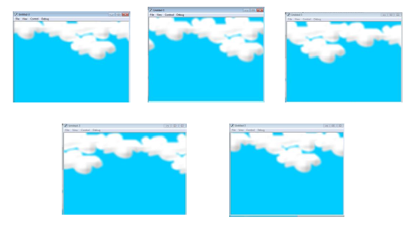

**Experiment: 4**

**Write down the procedure to draw the fan blades and to give proper animation.**

* Go to start-> macromedia-> click on flash document
* 2. Create a background on layer 1.
* 3. Insert another layer-> draw only fan blades and its circle.
* Insert another layer and draw fan stand.
* On each layer right click on frames and insert key frames.
* Select the fan blade’s layer and insert new key frame-> select the fan blades by free transform
* tool and rotate the circle a little bit.
* repeat the rotation until you get the fan rotation animation
* Go to control->test movie to see the animation.

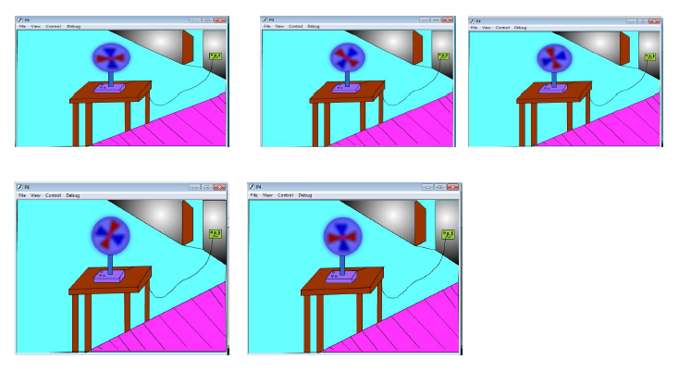**Output:**

**Experiment: 5**

**Write down the procedure to display the background given (filename: tulip.jpg) through your name.**

* Go to start-> macromedia-> click on flash document
* Go to file-> import->open external library-> select a background image Click open.
* The selected image will be stored in your library. Open library and drag the image on the work area by selecting the image.
* Resize the image to fit on the work area.
* Select the text tool from the tool bar.
* Type your name. Select the text and go to property to apply appropriate font effects like font size, style and Colour etc.
* Go to control-> movie clip to see the final output.

**Output:**

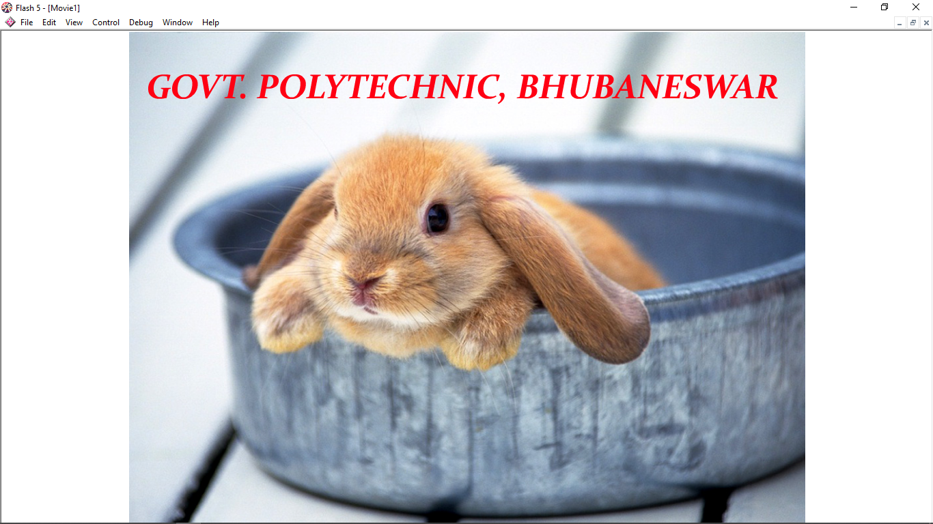

**Experiment: 6**

**Write down the Procedure to create an animation with the following features.**

* Letters should appear one by one
* The fill colour of The text should change to a different colour after the display of the full word.

* Go to start->Macro Media-click on Flash document.
* Choose the textbox from the tool bar. Type the word as ‘WELCOME’ on layer1.
* Select the complete word, increase its Font size and change the colour.
* In the timeline window, select the 1st frame-Right click on it-choose insert key frame.
* Now delete a last letter {E} and change the colour of the remaining word.
* Repeat the above procedure till you delete every word in ‘WELCOME’.
* Now select all the key frames->Right click ->choose ‘Reverse key frames’.
* After reversing the frames copy the last frame and paste on its next. now in the new frame
* Select all the complete word ‘welcome’ and change the colour.
* Finally, go to ‘control’-click on ‘test movie’ you will get the required animation.

**Output:**

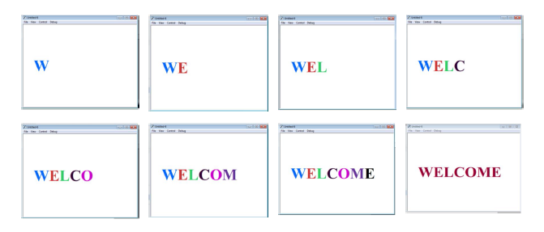

**Experiment: 7**

**Write down the procedure to design a visiting card containing at least one graphic and text information.**

* Open adobe Photoshop 7.0-> file-> new-> enter height 200 and width 400 for the

visiting card.

* Select the rectangle tool in the tool bar and draw on the half of the work area-> colour it.
* Repeat the same for remaining half-> use different colours to colour.
* Copy any picture of your choice and place it on the work area-> Resize it using transform

tool.

* Select the text tool and type text of your choice.
* Apply the text font size, colour and style of your choice.

**Output:**

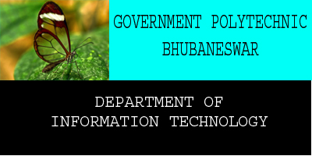

**Experiment: 8**

**Write down the procedure to prepare a cover page for the book in your subject area. Plan your own design.**

* open adobe Photoshop 7.0-> file-> new-> enter height 500 and width 400 for the cover

page.

* Select the rectangle tool in the tool bar and draw on the half of the work area-> colour it

Repeat the same for remaining area-> use different colours to colour.

* Copy any picture of ur choice and place it on the work area->resize it using free

transform tool.

* Select the text tool and type text of your choice.
* Apply the text font size, colour and style of your choice.
* Go to layer->layer style->blended option-> select glow options of your choice.
* Apply the effects using blended options.

**Output:**

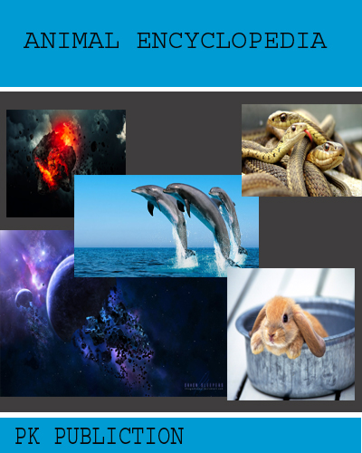

**Experiment: 9**

**Write down the procedure to adjust the brightness and contrast of the picture so that it gives an elegant look.**

* Open adobe Photoshop 7.0-> file->open-> choose a file and open it.
* Go to image->adjustments->Brightness/Contrast.
* After getting the Brightness/Contrast window adjust the brightness and contrast by

Dragging the appropriate bar setting.

* Finally save the image file.

**Output:**

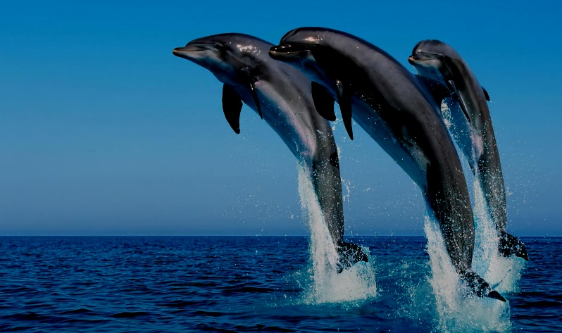

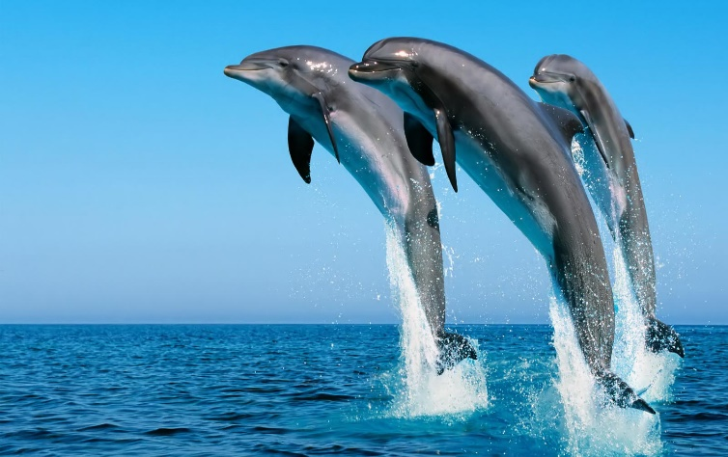

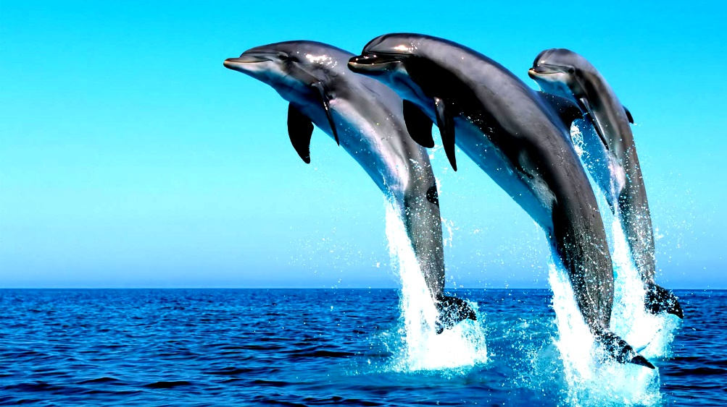

**Experiment: 10**

**Procedure to position the picture preferably on a plain background of a colour of your choice - positioning includes rotation and scaling.**

* Open adobe Photoshop 7.0-> file->open-> choose a file and open it.
* Select the flower from the image using the lasso tool.
* Go to edit-> copy->Again go to file->new->give height 500 and width 500.
* Choose appropriate background and foreground colour from the tool bar.
* Go to edit->fill->under use select background colour->ok.
* Go to edit->paste->again go to edit->free transform tool-> you will get a box around the

image for scaling and rotating.

* Rotate and scale as per your requirement->and press apply.
* Save the image.

**Output:**

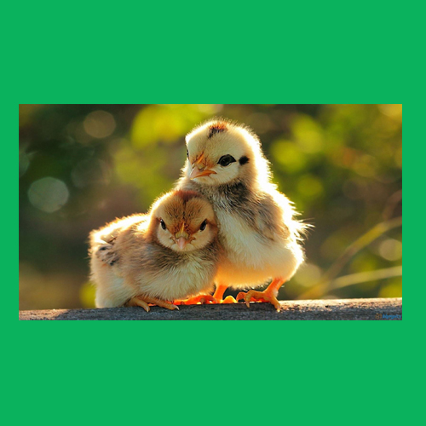

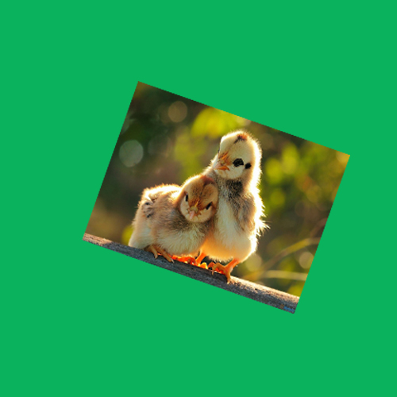

**Experiment: 11**

**Procedure to type a word and apply the effects shadow emboss.**

* Open adobe Photoshop 7.0-> file->open-> choose a file and open it.
* Select the text tool and place on the work area-> type your institute name
* Select the typed text go to layer->layer style->blended option-> tick drop shadow, inner

shadow, bevel and emboss->contour->satin->gradient overlay.

* finally save the image.

**Output:**





**Experiment: 12**

**Procedure to use appropriate tool(s) from the toolbox, cut the objects from 3 files (f1.jpg, f2.jpg & f3.jpg); organise them in a single file and apply feather effects.**

* Open adobe Photoshop 7.0-> file->open f1.jpg.
* Select the flower in it using lasso tool ->right click->feather-> give feather radius 20

pixels.

* Go to edit-> copy-> open a new file with height 500 and width also 500->paste the

flower.

* Repeat the same procedure for f2.jpg and f3.jpg-> select the flower ->give feather effect->

edit->copy-> open a new file-> paste.

* You will get o final single file with 3 flowers from different files.
* Save the new file.

**Output:**

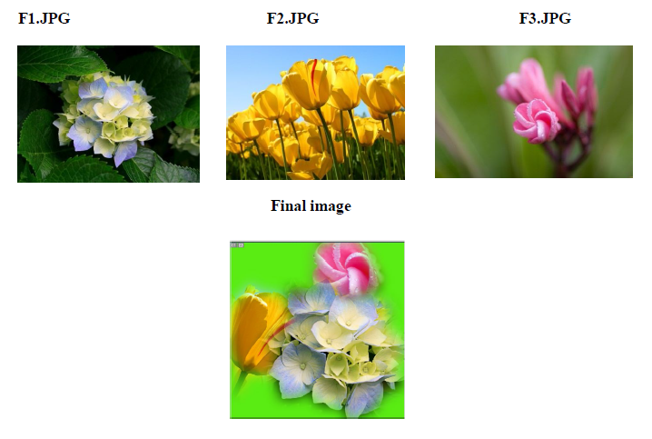

**Experiment: 13**

**Procedure to display the background given (filename: garden.jpg) through your name using mask.**

* Go to start-> macromedia-> click on flash document
* Go to file-> import->open external library-> select a background image

Click open.

* The selected image will be stored in your library. Open library and drag the image on the

work area by selecting the image.

* go to view->zoom out->resize the picture such that it should fit the work area.
* insert layer2. choose the text tool from the toolbar and type your name.
* Select the text to change its font size and colour of your choice. place the text on the left of

the workarea.

* Right click on the 70th keyframe of layer 2 and insert a keyframe. move the text to the

right side of the workarea->right click on the 69th frame of layer 2-> choose create motion

tween.

* right click on layer 2 choose the option mask.
* Go to control->test movie to see the animation.

**Output:**

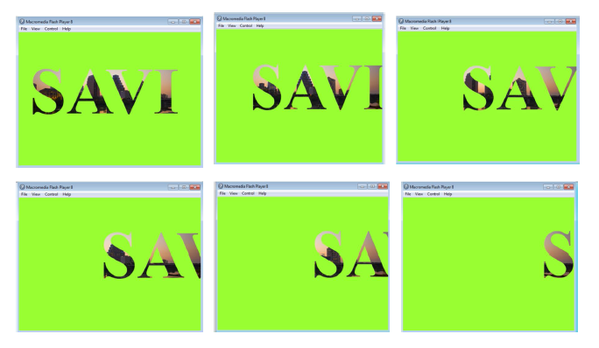

**Experiment: 14**

**Procedure to make anyone of one of the parrots black & white in a given picture.**

* Open adobe Photoshop 7.0-> file->open original parrot picture.
* Select a parrot using lasso tool from the tool bar.
* after selection->go to image-adjustments->desaturate.
* Then selected picture will now turn to black and white.
* save as modified image.

**Output:**

